1. Expose ports for two postgres pods:

kubectl port-forward example-postgres-0 5432:5432 -n activiti7

kubectl port-forward example-postgres-1-0 5433:5432 -n activiti7

1. Database connection settings:

Below three situation get issues:

1. Values-V1.yaml, requirements-V1.yaml

Two postgres pods:

Two postgres database:

The first one “example-postgres-0” has database: postgres-1

The seconde one “example-postgres-1-0” has two database: postgres, postgres-1

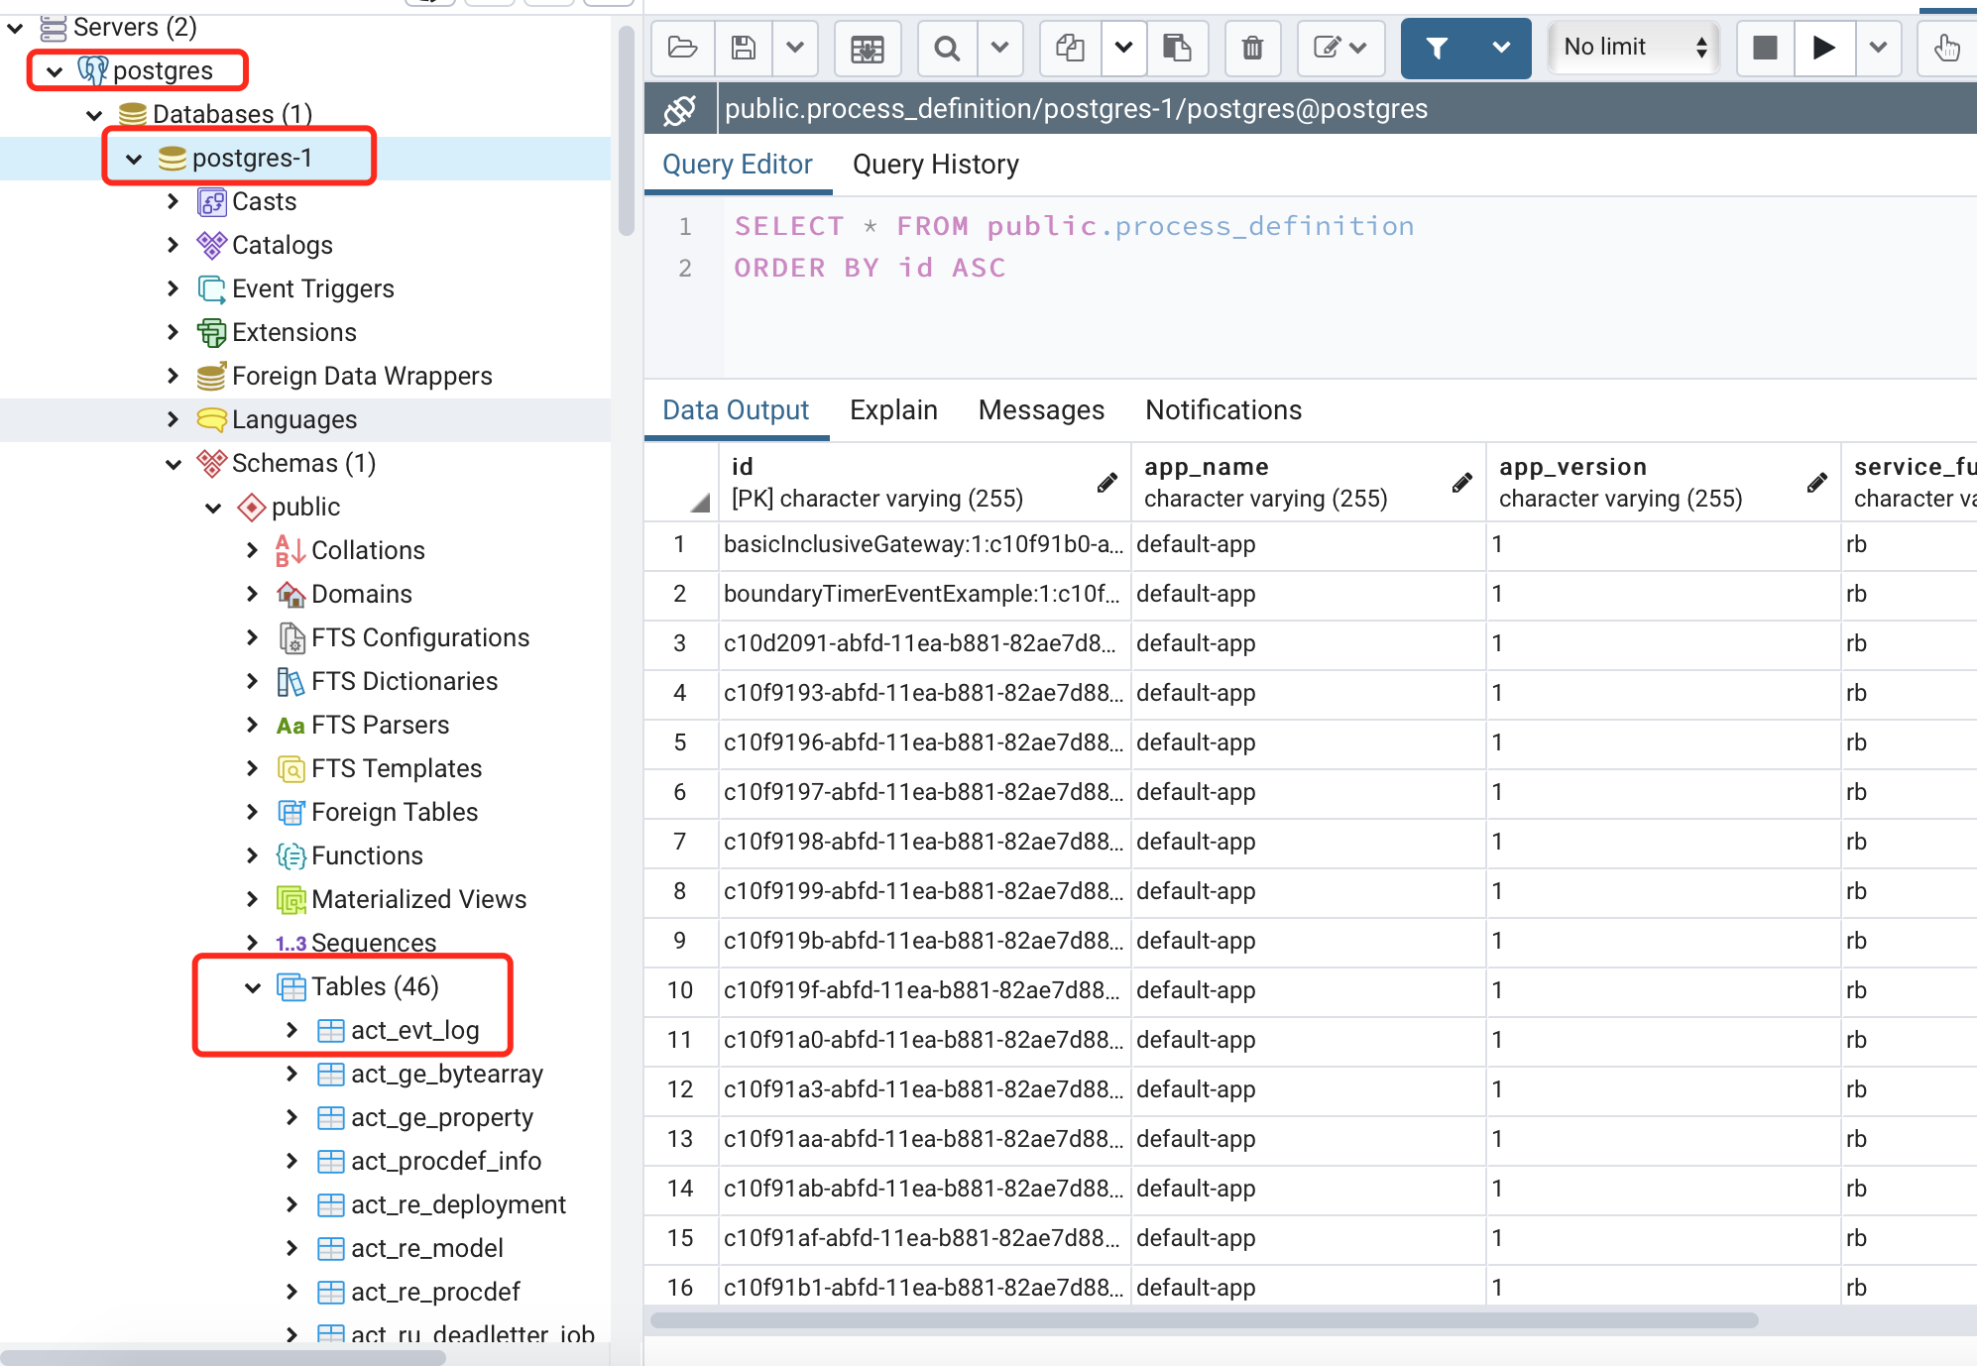

No data in db postgres of pod “postgres-1“

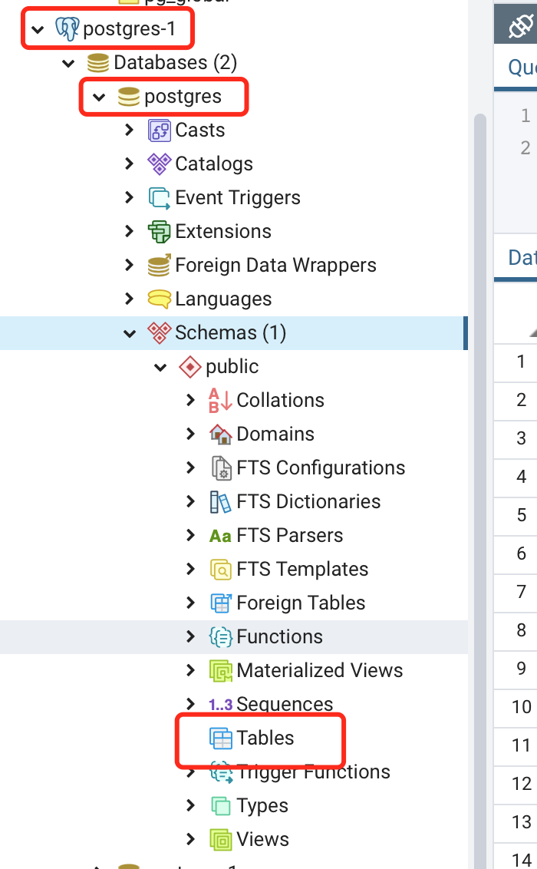

Has data in postgres-1 of pod ”postgres-1 “.

1. values-V2.yaml, requirement-V2.yaml

Create database “postgres-1” in pod “postgres”

Create database “postgres” in pod “postgres-1”

No data in process_defintion in database “postgres-1”

Two bundle process definition write to one database “postgres” in pod “postgres-1”

1. values-V3.yaml, requirments-V3.yaml

No database in pod “example-postgres-0”, two database “postgres” and “postgres-1” in pod “example-postgres-1-0”

No tables created in database postgres of pod “example-postgres-1-0”

46 tables will be created in “postgres-1” of pod “example-postgres-1-0”. BUT table “process_definition” will have data whose services name of runtime bundle which we want to write data to pod “example-postgres-0”

